**1 (a)**

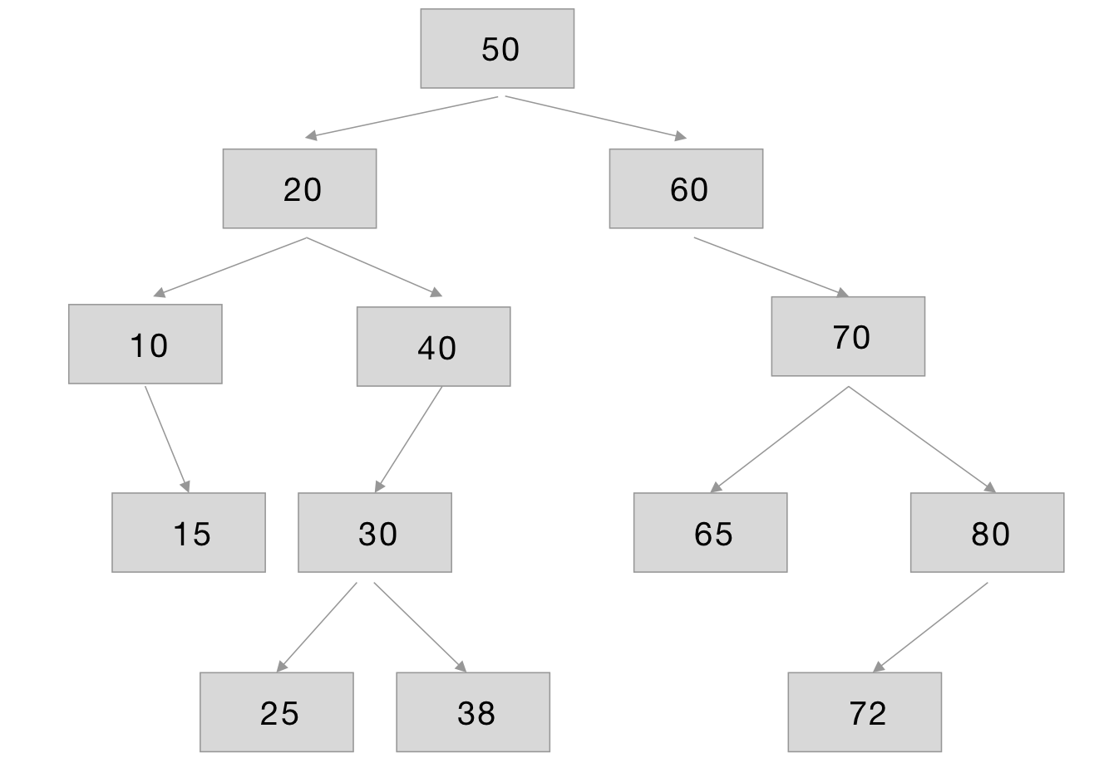

**1(b)**

In-order: 10, 15, 20, 25, 30, 38, 40, 50, 60, 65, 70, 72, 80

Pre-order: 50, 20, 10, 15, 40, 30, 25, 38, 60, 70, 65, 80, 72

Post-order: 15, 10, 25, 38, 30, 40, 20, 65, 72, 80, 70, 60, 50

**1(c)**

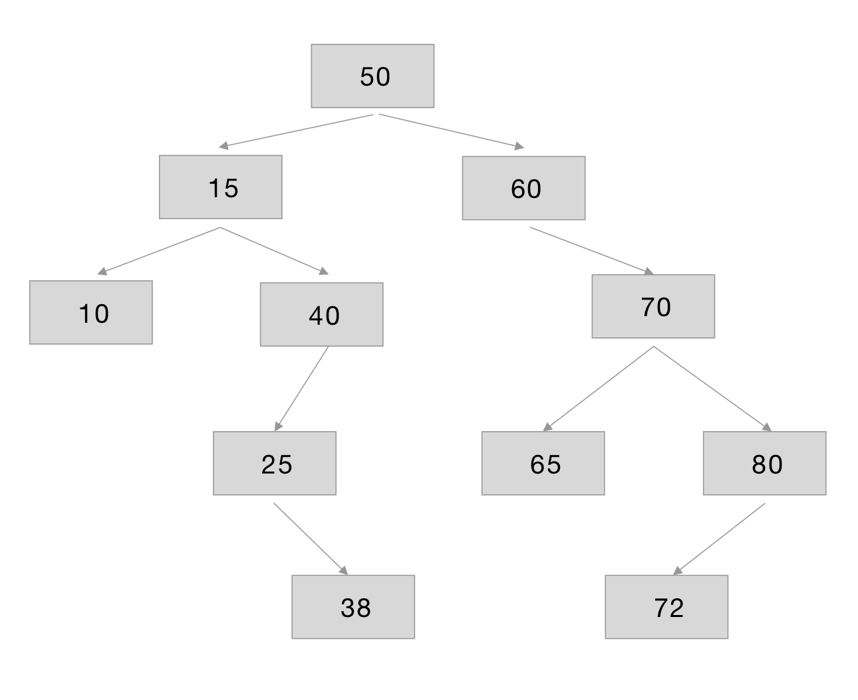

**2(a)**

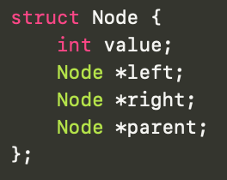

**2(b)**

*Node* insert(Node* node, int value)*

*If node is null, then*

*return a new node with value=value, left=right=parent=nullptr.*

*If value is less than node’s value, then*

*recursively call insert(node->right, value) and set node->right to returned node.*

*set node->right->parent to node*

*If value is greater than node’s value, then*

*recursively call insert(node->left, value) and set node->left to returned node.*

*set node->left->parent to node*

*Return node*

**3(a)**

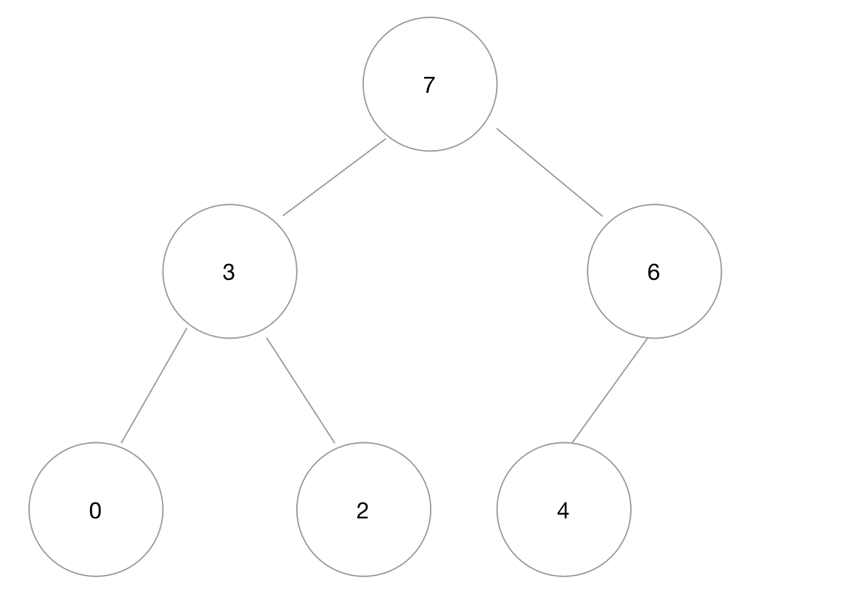

**3(b)**

7, 3, 6, 0, 2, 4

**3(c)**

6, 3, 4, 0, 2

**4(a)**

O(C) + O(S)

**4(b)**

O(logC) + O(S)

**4(c)**

O(logC) + O(logS)

**4(d)**

O(logS)

**4(e)**

O(1)

**4(f)**

O(logC) + O(S)

**4(g)**

O(SlogS)

**4(h)**

O(ClogS)